VISHNU V

Front-End Web Developer

I am a self-learned front-end developer and a self-motivated person. My goal is to become a MERN stack developer when I realize my path, I plan to switch my domain to front-end development and have started hard work to learn new skills. I currently have three years of experience as a content analyst at Bytedance India.
vishnusathyanathan@gmail.com

+91 8714413794

Banglore, India l Linkedin.com/in/vishnu-v-0789
https://github.com/vishnuvvv



WORK EXPERIENCE

Content Analyst

Bytedance

Bytedance is the parent company of Tik-Tok, Helo App, etc.
02/2019 - Present, Gurgaon/India
Achievements/Tasks
I have experience in different content moderation projects with deep knowledge of policy guidelines and have good proficiency in MS Excel.
can handle different projects simultaneously and have the efficiency to finish the assigned task according to the time-bound, provided constructive advice to improve the workflow.
During this work period, I highlighted critical cases in the platform to the higher authorities, which helped the firm to remove them and avoid the product risk.

EDUCATION
M.Sc. Electronics and communication systems Nehru arts and science college (Bharathiar-University)/Coimbatore.
05/2016 - 05/2018,
Courses
Project: Li-ﬁ technology

B.Sc. Electronics

Gems arts and science college (University of Calicut)/Malappuram, Kerala.
03/2013 - 03/2016,
Courses
Project: Wireless automatic bomb detection robot with spy cam

ACHIEVEMENTS

Spot bonus and Value-added certified skills from Bytedance For highlighting critical cases in the platform, which helped the firm to remove them and avoid the product risk

ORGANIZATIONS
NSS (national service scheme)
(03/2011 - 03/2013)

SKILLS
CSS
JAVASCRIPT
REACT.JS
HTML, BOOT STRAP
GIT, GIT HUB
Co
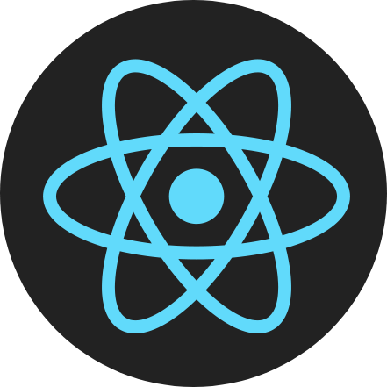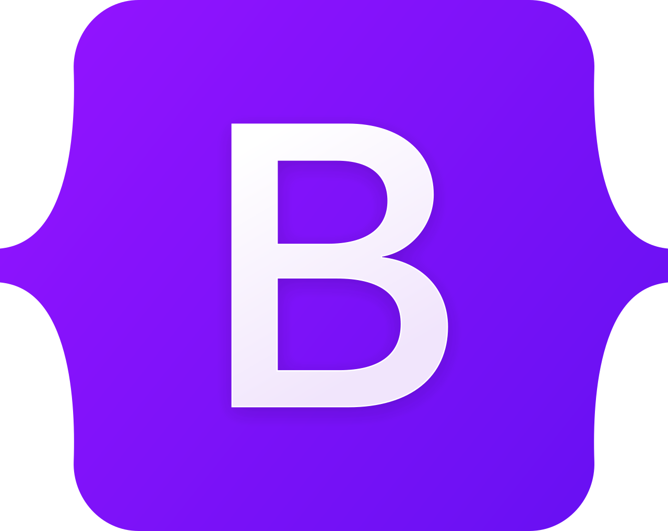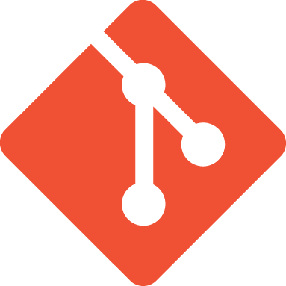

PERSONAL PROJECTS
1.BMI-Calculator(https://github.com/vishnuvvv/body-mass-index-calculator.git)

2.Contact Saver application(https://github.com/vishnuvvv/Contcacts-saver.git)

3.To-do list(https://github.com/vishnuvvv/todo-list.git)

CERTIFICATES
Certiﬁcation in Computer hardware (11/2010 - 02/2011)

Certiﬁcation in industrial automation (06/2018 - 12/2018)

LANGUAGES
English
Professional Working Proﬁciency

Malayalam
Native or Bilingual Proﬁciency

INTERESTS

Watching You tube, Reading Blogs

